Abstract
Modern construction projects demand integrated Digital Twin (DT) solutions across phases and domains. This paper proposes a Coupled–Composable Digital Twin (CCDT) framework for construction project management, treating a network of DTs as a system-of-systems (SoS). Each DT operates as a semi-independent module, yet they are dynamically coupled via real-time data flows. This composable approach promises to overcome fragmentation by enabling data exchange and coordination across domains, which is crucial for construction projects that could span multiple processes. Utilizing a probabilistic graphical model (PGM) approach, drawing on Bayesian inference to update posterior beliefs about system performance as new data arrive. Historical data and sensor inputs continuously calibrate the DT network, enabling proactive decision-making across the systems. The study examines the proposed approach using the manufactured housing system at each DT of the CCDT process and illustrates how these metrics inform system-wide interactions. The case study consists of 50 modular homes in a flood-prone region of Louisiana (each home composed of four prefabricated modules). The study demonstrates a mock CCDT implementation on the uGridd platform, leveraging its GIS/BIM integration to visualize the coupled digital twins and simulate cyber-physical-human interactions. Using external analysis software, the study conducts multi-objective optimization to explore trade-offs among KPIs. The results show that the CCDT approach can enhance interoperability in modular construction by enabling real-time insights and adaptive control that are not possible with siloed twins or static models.

Introduction
DT technology is transforming construction by creating virtual replicas of physical assets and processes that update in real time. Early applications often involved single, siloed twins for specific purposes. However, with increasing project complexity, including accelerated schedules, urban constraints, and numerous stakeholders, current DT implementations require multiple and interoperable DTs to mirror the entire construction life-cycle. There is growing recognition that multiple specialized twins must interoperate within the SoS architecture to fully realize their potential. For instance, Shahat et al. (2021) highlight the challenge of consolidating information across a city's subsystems into a single digital platform and advocate for a SoS approach to city digital twins. Similarly, Wan et al. (2019) argue that deploying multiple domain-specific twins (e.g., transport, utilities, buildings) is more effective than pursuing a single monolithic city model. These insights suggest that composability, the ability to integrate modular DTs, is key to managing complex construction projects. Each DT operates semi-independently while integrating through shared ontologies and communication protocols (Zhang et al., 2024).
In the construction domain, coupling of DTs can facilitate the actual project workflow of construction processes, as it inherently spans geographically and functionally disparate systems. However, current practice often treats these DTs separately, resulting in data gaps and inadequate decision-making. The absence of automatic detection of hidden DT interactions leads to coordination blind spots. For example, Jiang et al. (2023) document that in modular integrated construction, information silos or "islands of information" persist between off-site production and on-site assembly, hindering synchronized collaboration. Their study emphasizes the importance of flexible collaboration among heterogeneous digital twins and the exchange of real-time information among stakeholders to enhance project outcomes. This silo effect delays awareness of project changes, often revealing issues only after some time or not at all. The absence of real-time insight into cross-system impacts is a significant weakness. Without identifying hidden interactions, teams risk schedule conflicts, resource underuse, or quality problems that spread throughout the project. However, there is also vacant potential within these interactions. If a hidden dependency is identified, the project can respond proactively.
A key emerging challenge in multi-DT systems is managing the hidden interactions and interdependencies among twins. When multiple DTs operate in parallel, their physical counterparts, such as machines, material, crews, and context, are inevitably influenced by one another, and their digital models may exchange data or trigger actions in ways not immediately apparent to stakeholders. Undetected, these hidden interactions can lead to data inconsistencies, control conflicts, or cascading errors. However, if identified and leveraged, they offer new opportunities; one twin's data might preemptively warn another of a risk, or combined insights from two twins might reveal an optimization that neither could see alone. Detecting and understanding these latent digital-to-digital and physical-to-digital linkages is therefore vital for harnessing the full power of a coupled digital twin system.

Literature Review
Early DT adoption in construction and infrastructure has paved the way for integrated, multi-domain systems. Castelli et al. (2019) introduced one of the first city-scale digital twin concepts, describing an "urban intelligence" model that is modular, fully integrated, and continuously evolving. This aligns with the SoS philosophy, enabling digital twins to interoperate across the construction life-cycle (Lin et al., 2024). This involves multiple interconnected models that, along with co-evolving, can integrate different urban subsystems such as transportation, utilities, and buildings. Likewise, city digital twin reviews by Shahat et al. (2021) emphasize the need for platforms that can manage city complexity by integrating information across domains and stakeholders. These city-level insights are well-suited to building-scale projects; the main challenge remains integrating heterogeneous data and models. Radenković et al. (2020) noted the potential of "loosely coupled" models to overcome the complexity of the physical counterpart and its multiple domains. Patterns like loose coupling, semantic mediation, and federated orchestration promote a resilient SoS model (Lin et al., 2024).
The integration of the complex system digital twin involves three main aspects. The first aspect is the virtual model, where creating multiple DTs could be more effective than developing a single model that encompasses all the systems and processes (Wan et al., 2019; Lin et al., 2024). The second aspect is promoting collaboration among the diverse stakeholders. Utilizing online and open platforms enhances data sharing and encourages stakeholder involvement in planning, development, and evaluation (Soman et al., 2025; Yan et al., 2025). Finally, Hidden interactions among twins can lead to data inconsistencies, conflicts, or errors. Recognizing these interactions provides opportunities to transmit risks or identify optimizations that neither could achieve on its own.
Integrating IoT and sensor data into construction twins has also been investigated. Radenković et al. (2020) demonstrated a distributed IoT framework for modeling dynamic behaviors in smart environments, illustrating how streaming data from sensors, RFID, GPS, and other sources can update digital models to mirror the physical world in near real-time. In construction, these IoT integrations instantly update the project's digital records, allowing the twin to capture the project's timestamped condition, which is vital for scheduling and quality control. This underscores a key trend: combining multiple systems through data and analytics is essential for the future of construction digital twins.
Another thread of relevant research is the application of probabilistic methods to digital twins. Kapteyn et al. (2021) provide the theoretical foundation by formulating the DT as a probabilistic graphical model (PGM) that captures the relationships between physical states, digital states, observations, and actions. The benefit of this approach, as they demonstrated in an aerospace example, is the ability to formally update the digital twin's state estimation when new data, such as sensor readings, becomes available, essentially performing Bayesian inference to obtain a posterior state estimate. In doing so, the digital twin is not a static mirror but a learning entity that improves its accuracy over time. This approach is instrumental in construction, where uncertainties are considerable, for example, actual task durations vs. planned, weather impacts, etc. While not many construction DT projects have yet adopted a complete Bayesian network (BN), there is growing interest in using probabilistic simulations for predictive maintenance and risk forecasting. For instance, BNs have indeed been applied in the facility management domain for predictive maintenance and equipment failure forecasting. For example, Bortolini and Forcada (2017) propose a BN-based approach to predict the condition of building systems for maintenance decision-making. Their study highlights how a probabilistic model, a Bayesian network, can incorporate various factors influencing building component health to anticipate failures and optimize maintenance schedules. Similarly, a recent digital-twin study by Hosamo et al. (2023) integrates a Bayesian network model with sensor data and occupant feedback to detect and predict HVAC equipment issues in buildings, enabling proactive maintenance interventions in facility management. These examples demonstrate growing academic interest in using the BN technique for predictive maintenance of building equipment and infrastructure.
By analogy, the same probabilistic reasoning can be applied to project delivery risks. Research in construction management has used BNs to model and forecast project delays and cost overruns. For example, Luu et al. (2009) utilized a BN to quantify the probability of schedule delays in construction projects. Likewise, recent work employed a BN classifier to capture interdependencies among risk factors and successfully predict cost overrun outcomes in construction projects (Ashtari et al., 2022). These studies illustrate that while full BNs are not yet widespread in construction digital twin applications, the methodology is well-founded in related fields, supporting that BNs could predict schedule delays or cost overruns in construction just as they have been used to predict equipment failures in facility management. This work is among the first to explicitly apply a PGM-based method to a construction twin covering multiple DTs. By doing so, the study aims to incorporate uncertainty modeling and belief updating directly into the construction decision loop, which goes beyond traditional techniques.
Moreover, the study considers human factors and data governance literature. Human feedback loops promote adaptability and transparency (Castelli et al., 2019). DT researchers increasingly note that a twin is only as useful as the decisions it informs. Soman et al. (2025) discuss human–digital twin interfaces (HDTIs) that enable project managers, field engineers, and even citizens to interact with the twin system in intuitive ways, thereby improving trust and decision quality. This could include dashboards showing KPI trends, alerts pushed to mobile devices, or interactive simulations for training. The study framework design suggests such an interface, allowing users to visualize geospatial data, GIS maps, module locations, 3D BIM models, and real-time sensor feeds on a unified web interface. Likewise, Yan et al. (2025) highlight the importance of maintaining a CDE for connecting and scaling DTs from a single subsystem to the entire system. It is implemented as a cloud-based data repository, combined with a project management database that stores BIM files, sensor databases, schedules, and logistic information, and even unstructured data such as photos and inspection reports. This ensures that each digital twin module draws from and contributes to the same data pool, avoiding version conflicts and fragmentation, and facilitating cyber-physical-human interaction.
In modular and prefabricated construction, Jiang et al. (2023) developed a blockchain-enabled DT collaboration platform for Modular Integrated Construction (MiC) fit-out operations. Their platform uses a shared record and IoT devices to ensure that off-site production and on-site assembly data are synchronized transparently. A key finding from that work is that conventional project delivery creates information islands; for example, manufacturing, logistics, and assembly might use separate tracking systems. In contrast, a unified platform can eliminate redundant data entry and delays. The MiC study demonstrated that multidimensional information, such as BIM, schedule, and cost, can be updated and visualized in high-fidelity digital twins for real-time monitoring of resource status and progress. This visibility allowed stakeholders to make collaborative decisions and modify plans based on actual progress. The CCDT framework also promotes seamless data sharing. However, it extends beyond a specific blockchain to a broader SoS architecture that can incorporate hidden integrations to predict posterior beliefs and improve system performance.

Problem and Research Gaps
The existing research provides pieces of the puzzle, including modular DT architectures, IoT integration, probabilistic modeling, human interfaces, and CDE best practices. The contribution of this paper is to synthesize these elements into a coherent framework to manage the hidden interactions and interdependencies that arise among the twins. When multiple DTs operate in parallel, their physical counterparts, such as machines, material, crews, and context, are inevitably influenced by one another, and their digital models may exchange data or trigger actions in ways not immediately apparent to stakeholders. Undetected, these hidden interactions can lead to data inconsistencies, control conflicts, or cascading errors. However, if identified and leveraged, they offer new opportunities; one twin's data might preemptively warn another of a risk, or combined insights from two twins might reveal an optimization that neither could see alone. Detecting and understanding these latent digital-to-digital and physical-to-digital linkages is therefore vital for harnessing the full power of a coupled DT system. This study illustrates how a CCDT framework can overcome the limitations identified in prior work (silos, static models, and poor interoperability) and improve communication within a challenging SoS environment.
To systematically address this, the study identifies four overlooked types of hidden interactions in a multi-DT environment. First, Physical–Physical (PT–PT) Interaction: unseen couplings where one physical process affects another without digital signals, such as material flow constraints, spatial conflicts, or resource competition. For example, the delivery of material connects logistics and site work systems physically; if material is damaged in transit or arrives out of sequence, it physically alters site work. Second, Digital–Digital (DT–DT) Interaction involves hidden communication between digital twins' software or data, such as indirect data sync, shared algorithms, or duplicate entries that influence one twin's state and impact the other's calculations. For example, a planning DT might update a timeline used by the logistics DT; if not well integrated, updates could conflict, or if integrated, predictive bias might occur. Undetected DT–DT links can lead to inconsistent system views or be used for real-time consistency by sharing forecasts. Third, Physical–Digital (PT–DT) Interaction occurs when a physical twin's state affects a digital twin, like real-world events triggering updates in another DT's model. For example, a factory machine breakdown might cause delays that only show up as late site work DT after analyzing sensor data. Detecting these interactions early allows the DT to adjust predictions, like revising schedules after sensing delays via IoT data. Finally, Digital–Physical (DT–PT) Interaction involves hidden links where a digital twin influences physical processes across domains. For example, a construction DT detecting a defective component arriving at the site might trigger a reorder. These interactions can automate actions that affect other subsystems, increasing the risk of coordination issues such as miscommunication or disruptions. However, with proper management, they can also help prevent physical problems by enabling timely, informed decisions.
The research gap lies in the lack of frameworks for detecting, modeling, and leveraging these four categories of hidden interactions (PT–PT, DT–DT, PT–DT, and DT–PT). Current multi-DT implementations focus on linking data, but they do not explicitly represent how one twin's state might covertly influence another's outcomes. This paper addresses that gap by hypothesizing that such hidden interactions not only exist in a CCDT system but also carry significant functional implications: if harnessed, they can improve situational awareness and system performance; if ignored, they pose risks to data integrity and project coordination.

Research Questions and Hypothesis
Based on the identified gaps, the research suggests that hidden interactions in multi-DT systems are both common and significant. The study frames the investigation with these research questions:
- What kinds of hidden interactions exist among the physical and digital states of different twins in a construction project?
Significance of RQ1: Digital twins are often viewed as separate entities, but in complex environments, their physical and digital states can indeed influence each other. Discovering these hidden interactions helps us understand how multiple subsystems, each with its twin, operate as a united system. By identifying these previously unnoticed connections—such as a sensor on one twin's physical asset affecting the data stream of another twin's model—we can prevent blind spots in system design and avoid unexpected issues. In short, mapping the unseen physical–digital interactions among various twins is crucial for a comprehensive understanding of the whole system, enhancing coordination and revealing emergent behaviors that isolated models might overlook.
Hypothesis 1: Multiple hidden interactions exist between the physical and digital states of different digital twins in a construction project. Specifically, it is expected that no twin operates in complete isolation; data flows and physical conditions will connect the twins. For example, a twin's physical state, like defects or temperature changes, might influence another twin's sensor readings, or one twin's digital model could depend on input data from another's physical twin. Therefore, the hypothesis is that these unintended connections are present and can be systematically detected. It is anticipated that identifying cases where a change in one twin's environment or data affects another twin's behavior or accuracy will confirm that these hidden inter-twin interactions are real and significant.
- Do such interactions offer opportunities for added value (for example, improved prediction, efficiency), and what risks might they pose to system integrity and coordination?
Significance of RQ2: Understanding these interactions can be valuable; they could be used to add value, such as combining data from different twins to improve predictive accuracy or operational efficiency across a project. However, unrecognized interactions might pose risks; a problem in one twin could spread to others, potentially compromising system integrity or causing coordination issues. Exploring both opportunities and risks allows for proactively boosting benefits, such as better forecasts and streamlined processes, while reducing negatives, such as cascading errors or control conflicts. For example, the same IoT sensor network might supply data to both the building's energy-management twin and its structural-health twin. This shared data can improve predictions; for instance, the structural twin can use real-time temperature data from the climate control system to forecast material expansion better and enhance overall efficiency. Nevertheless, a sensor fault or incorrect data could mislead multiple twins at once, threatening system integrity if not adequately managed. This example highlights the importance of assessing both the added value and the risks of unseen interactions to apply digital twins in construction effectively.
Hypothesis 2: These hidden interactions are indeed a double-edged sword; they will provide tangible benefits but also introduce new risks. On the opportunity side, leveraging interactions is expected to improve project outcomes; for example, integrating insights across twins will lead to more accurate predictions, faster decision-making, and efficiency gains through data sharing and learning between the twins. Conversely, these interactions could create vulnerabilities; in particular, a fault, delay, or miscommunication in one twin might propagate to others. In other words, hidden couplings might cause cascading effects in which an error or change in one part of the system affects the rest. The hypothesis is that if such inter-twin linkages are unmanaged, they could compromise system integrity or coordination, for instance, leading to inconsistencies between twins' outputs or control actions. Overall, it is anticipated that while these interactions can add significant value, such as better predictions and improved efficiency, they also increase the need for robust oversight to prevent systemic risks.
- Do these hidden interactions affect one another, thereby creating interdependencies?
Significance of RQ3: This question examines whether the hidden interactions identified are isolated or part of a connected network of effects. Its importance lies in understanding the complexity of the digital twin ecosystem. If these hidden interactions influence one another, meaning that changes in one interaction affect others, then the digital twins are interdependent rather than independent. This has significant implications: interdependencies could cause feedback loops or compounded effects, where managing one twin or interaction requires awareness of the others. Recognizing this interdependence is crucial for effective system-wide decision-making and change management. It suggests that improvements or failures will not happen in isolation; instead, a change in a subsystem might create ripple effects elsewhere. Broadly, confirming interdependencies would support a more integrated approach to design and operations, as subsystems demonstrate their influence on one another across all levels within a system. Understanding this helps prevent siloed optimizations that unintentionally weaken other subsystems and ensures that coordination strategies account for the twins' interconnected nature.
Hypothesis 3: The study suggests that these hidden interactions do not exist in isolation; instead, they influence one another and form a network of interdependencies among the digital twins. In practice, this means expecting that a change in a single hidden interaction, such as how one twin shares data with another, will have downstream effects on other interactions or twins. The subsystems in the construction project are likely to act as a linked system, in which feedback and chain reactions occur: a change or disturbance in one twin's state can spread through the hidden links and affect the performance or behavior of other twins. In summary, the hypothesis is that these interactions will prove to be mutually reinforcing or inhibiting, confirming that the twins depend on one another. It is expected to find evidence of this interconnected behavior, such as a scenario where updating Twin (X) affects Twin (Y), which in turn influences Twin (Z), and possibly circles back to affect Twin (X), demonstrating that a system of digital twins functions as an integrated whole rather than a collection of separate parts.
The study hypothesizes that four types of hidden interactions, Physical-Physical (PP), Digital-Digital (DD), Physical-Digital (PD), and Digital-Physical (DP), exist within a coupled digital twin network and can be systematically identified using a probabilistic model. It further suggests that, once recognized, these interactions offer operational benefits such as cross-domain feedback loops that improve decision-making and reliability. However, they also introduce coordination risks if not managed carefully. Essentially, these four types of hidden interactions form an implicit connectivity layer often ignored in traditional analysis. The study aims to show that understanding this hidden layer enables the CCDT system to coordinate multiple subsystems more effectively than operating each twin separately. At the same time, increased coupling could cause disturbances to spread more widely; thus, maintaining the integrity of information flows and actions across twins is a key focus. This hypothesis will be tested by developing a model to identify these interactions and applying it to a case study, with the expectation of finding evidence of all four interaction types, supporting the idea that concealed DT interactions are fundamental and can be utilized.

Methodology
To investigate and validate the hypothesis, the study uses a multifaceted methodological approach that combines mathematical modeling, probabilistic graphical analysis, and a practical case study. The methodology includes the following steps:
- Abstract Mathematical Model of Modular DTs:
The study was designed to enable scalable modeling of multiple twins and to mathematically demonstrate how one twin's state variables can influence another twin's update equations, even when hidden interactions occur. First, it formalizes a state-space model for the CCDT system. Each DT is considered a dynamic subsystem with its state variables. It defines a generalized state vector for each twin at timestep (t), including Digital state (D), Physical state (Pᵗ), Sensor (S), Action (Aᵗ), Reward (Rᵗ), and Process of Interest (Eᵗ). Additionally, each twin (i) within the system can be represented by its state tuple Xiᵗ = {Diᵗ, Piᵗ, Siᵗ, Aiᵗ, Riᵗ, Eiᵗ}.
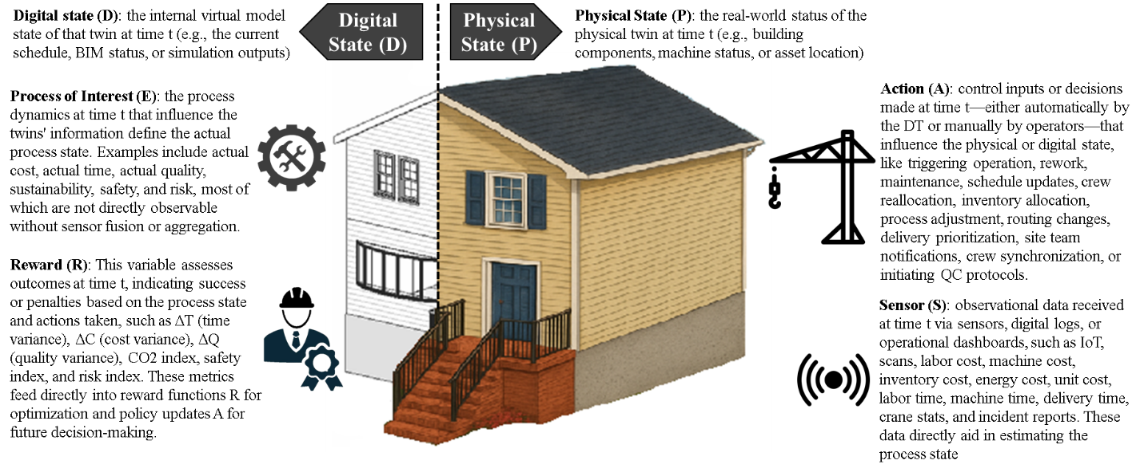
These variables evolve over discrete time steps t $ϵ$ { t-1=Initial timestep, t=current timestep, and t+1=Future timestep} as the project progresses. Then, conceptualize the Coupled–Composable DT (CCDT) as a network that manages twins and their interactions at all levels, i.e., within twin variables and across the fleet of twin variables. In this model, each twin acts as an agent with localized state coordination, while a top-level coordination mechanism (the coupled fleet layer) consolidates and aligns their states. This structure supports a decentralized control approach at the subsystem level (each twin optimizes its domain) and centralized coordination at the fleet or system level (ensuring the twins stay in sync toward overall system goals) by framing the problem in state-space form.
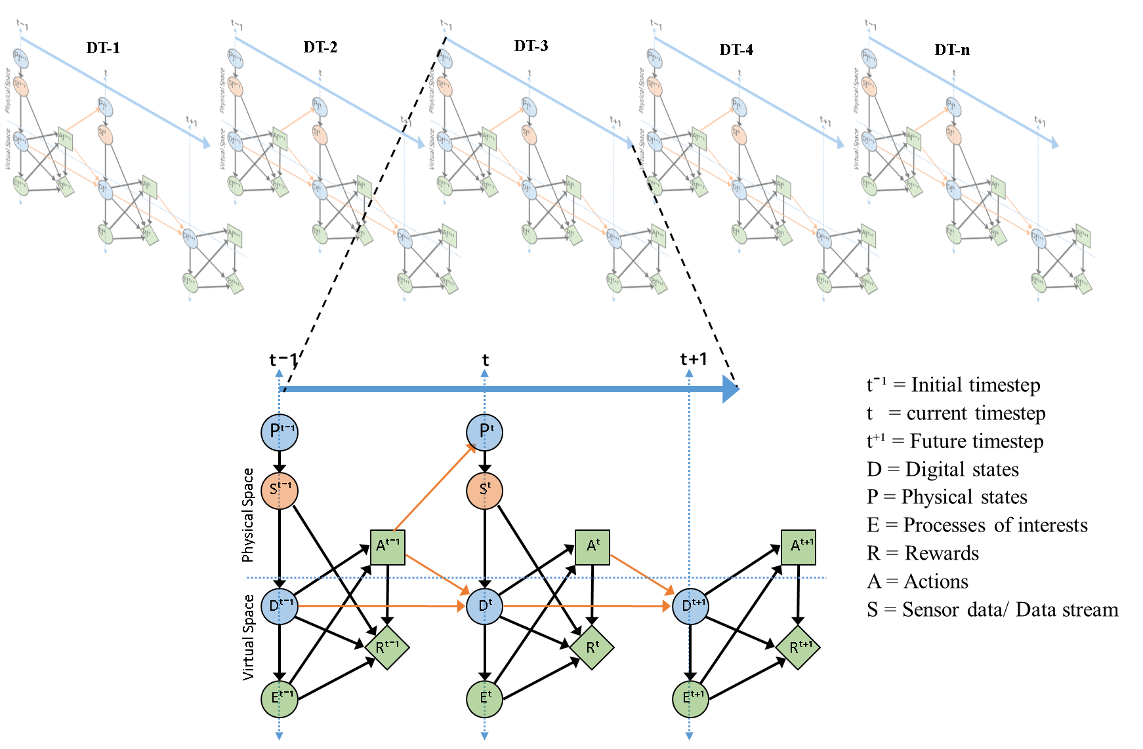
Formally, this defines the state transition and observation equations, including cross-terms. For example, in the case study scenario of manufactured housing, the digital state of the on-site assembly twin at the next time step (Doᵗ⁺¹) might depend not only on its previous state (Doᵗ) and local sensor inputs (Soᵗ), but also on the physical state of off-site fabrication (Pfᵗ) and the digital state of logistics (Dlᵗ), since those inform how many modules are arriving and when. This introduces coupling terms in such equations to capture hypothesized links, for example, a term for "if factory delay (Pfᵗ) then assembly (Doᵗ⁺¹) triggers a schedule shift." This abstract model provides a blueprint that explicitly includes potential hidden interaction pathways (PT–PT, PT–DT, etc.) in the state update logic.
- Identification of Hidden Interaction Types:
Next, the study identifies specific examples of the four interaction categories within the construction context. This involves explaining how each category appears in the system architecture.
- PhysicalPhysical (PP): This identifies all points where physical processes interface. Also, it is considered an indirect relationship that operates through a mediator such as transportation. In the case study, this includes the flow of materials through logistics. Because modules physically travel from the factory (off-site) to the site (on-site), a physical connection exists.
- PhysicalDigital (PD): This describes how a physical event in one subsystem should be reflected in another subsystem's digital model. In the case study scenario, production status triggers planning updates. When a module is completed in the factory (off-site physical), it should trigger the (on-site digital) to update the schedule that the module is ready and in transit. Additionally, this is a sensor-driven case that represents an indirect (PD) interaction mediated by sensor data, like a tilt sensor on a module (physical state), updating the logistics DT's model of transit risk (digital state).
- DigitalDigital (DT–DT): Describe how data moves directly between digital twins' subsystems. In the case study scenario, real-time synchronization of virtual subsystem data is essential, for example, when the off-site DT's production schedule and the on-site DT's assembly schedule exchange information to ensure coordination. This highlights the data fields and messages shared through the integration middleware, such as schedule milestones, inventory levels, or delivery ETAs, as DT–DT couplings. These can be multidirectional or bidirectional. For example, the manufacturing DT might send an event, "module X fabrication complete," to both the logistics and assembly DTs (a one-to-many digital update). In contrast, the assembly DTs reply with an inspection report for the module that arrived: "Component X-001 of module X is defective". Also, consider whether twins use shared databases, such as both accessing a central BIM model in the cloud, which effectively connects their digital states.
- DigitalPhysical (DTPT): Identify where a decision or output from one DT impacts a physical operation elsewhere. In the modular workflow, an on-site digital state request for rework occurs. If the assembly DT detects a module defect, it digitally requests the factory to re-fabricate that module, thereby changing the factory's physical production schedule. Another example is logistics adjustments. Suppose the logistics DT's simulation detects a risk due to weather forecasting or traffic congestion on the planned route. In that case, it may instruct a truck driver to take an alternate route (physical action). This highlights DT-driven commands or changes that influence real-world behavior in other subsystems. Additionally, this is another indirect case of interaction mediated, for example, by an actuator or human.
For each relationship, the study captures not only the planned (designed) interactions but also any unintended or hidden ones uncovered. For example, it might discover that workers on-site physically compensate for delays without a formal digital record, that PT (PT interactions that are not digitized) are not recorded, or that a workaround spreadsheet duplicates data from DTs (DT interactions outside the official system). By creating this comprehensive interaction map, the foundation for analysis is established; it shows the pathways through which hidden influences can spread. Notably, it may be helpful to include a "sensor fusion layer" and a "common data environment" in this mapping, which act as mediators for specific interactions. Sensor fusion (combining IoT data from different subsystems) facilitates cross-domain awareness (for example, linking site environmental sensors with factory conditions). Meanwhile, the CDE ensures all DTs refer to the same data instances. Incorporating these layers into interaction identification will help detect indirect couplings, such as two DTs both relying on the same weather sensor feed.
- Probabilistic Graphical Model (PGM) and Conditional Probabilities:
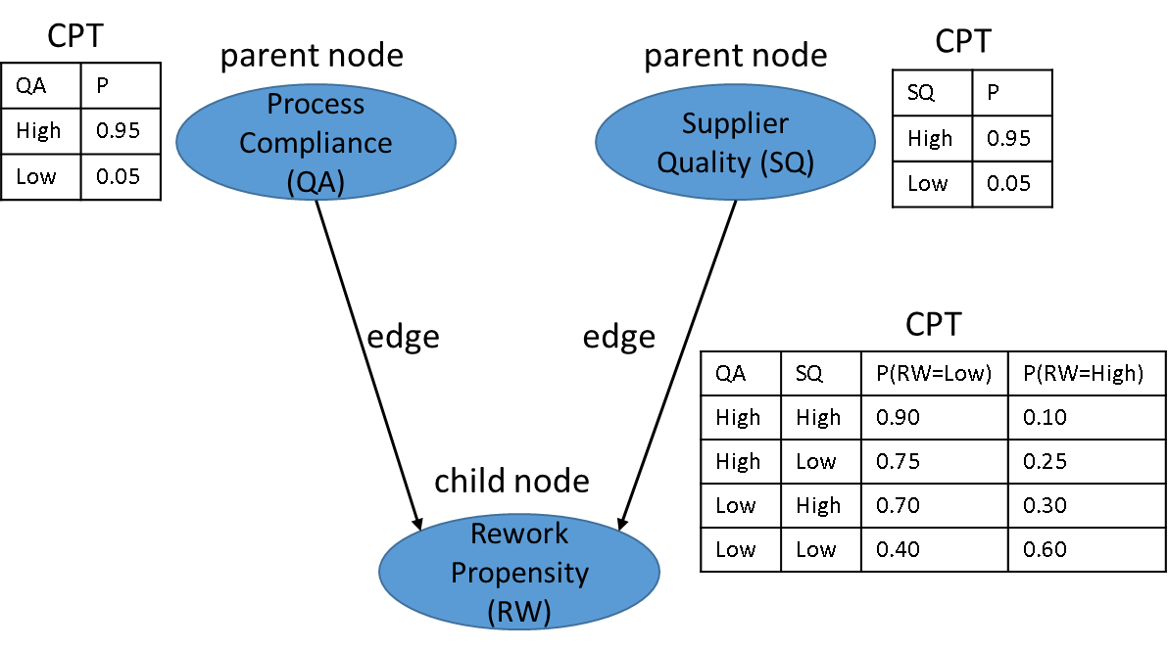
To accurately detect and quantify hidden interactions, a probabilistic graphical model (PGM) of the coupled DT system was developed. This PGM is essentially a Bayesian network, or dynamic Bayesian network, given its time component, where nodes represent state variables (or events) of the different twins, and edges represent probabilistic dependencies or conditional influences between them. By designing the graph to include nodes for the key state elements of each DT (D, P, S, A, R, and E) and connecting nodes across twins where interactions are suspected, this creates a formal structure that encodes conditional probability relationships among the twins. For the case scenario, an edge from "Factory (Pf)" to "Site (Do)" would suggest that a delay in the physical off-site twin (Pf) increases the likelihood of a delay in the on-site digital twin's (Do) schedule. Each link is quantified with a conditional probability table (CPT) that can be learned or estimated from data. This populates the Bayesian network with prior and conditional probabilities based on both historical data, such as past modular projects, which help understand how delays propagate, and domain expertise. For example, it might set an initial conditional probability P(On-site delay | Off-site delay) = 0.7 based on past trends showing off-site issues often lead to on-site slowdowns to some degree. These probabilities are updated as real-world case study data become available, using Bayesian inference to revise confidence in each interaction.

The digital state vectors of each twin are computed or updated through inference on this network. As new evidence arrives, such as a sensor indicating a truck delay, the PGM updates the distributions of related state variables, like the probability of meeting the assembly deadline, across the network. The model learns the hidden interactions by adjusting the conditional probabilities. If a particular cross-twin influence is strong, the data make CPT more skewed, indicating greater dependence. This approach also incorporates the temporal aspect, from time t-1 to t+1, in a dynamic Bayesian network, capturing how an earlier state of one twin influences a later state of another, such as yesterday's factory output rate affecting today's site progress. Key variables in the PGM come from the state-space model (D, P, S, A, R, and E) for each twin. By analyzing the correlations and conditional probabilities in the graph, the model can identify hidden interactions when two nodes from different twins develop a significant probabilistic link, such as high mutual information or a CPT far from independence, indicating a hidden interaction within the system's behavior. This method moves beyond guesswork by providing quantitative evidence of how strongly one twin's state affects another's. All CPT parameters and model updates are stored in the shared data environment, making the CDE a repository not just for raw data but also for the evolving, integrated digital state of the entire system.
Mathematically, the PGM enables the calculation of posterior distributions for each twin's state conditioned on the others. For example, in the case study scenario:
$∅^{state}=$p(Dfᵗ, Doᵗ ∣ Dfᵗ־¹, Doᵗ־¹, Afᵗ־¹, Aoᵗ־¹, Sfᵗ, Soᵗ)
A conditional probability that directly answers "given the previous digital states of off-site and on-site(Dfᵗ־¹, Doᵗ־¹ ), previous actions taken off-site and on-site (Afᵗ־¹, Aoᵗ־¹ ), and current sensor data off-site and on-site (Sfᵗ, Soᵗ), what is the likelihood that the off-site and on-site digital state at the current timestep t will be (Dfᵗ, Doᵗ)?" If this differs from the unconditional or independent case, it confirms an interaction.
The study defines an interpretation layer that links digital states to the detection of events or processes of interest across multiple twins. For example, in the case study scenario:
$∅^{event}=$p(Efᵗ,Eoᵗ ∣ Dfᵗ,Doᵗ)
Where (Efᵗ) denotes the event state of the off-site (factory) twin at time t, and (Eoᵗ) indicates the event state of the on-site twin at time t. The conditional distribution is defined by the digital states of the two twins (Dfᵗ and Doᵗ). This formulation describes the joint probability of observing specific events across domains (e.g., factory manufacturing progress and site delivery confirmation) based on contemporaneous information stored in the digital twins.
In practice, this layer of interpretation serves as a link between raw digital state variables and higher-level events or KPIs. It allows the PGM to identify, at each timestep, which features or processes are most relevant for inference and decision-making. For example, if (Dfᵗ) indicates a "90% fabrication complete" status, and (Doᵗ) signifies "awaiting delivery," then the conditional distribution assesses the likelihood that the events Efᵗ = (module completed) and Eoᵗ = (delivery confirmed) will occur together. This way, the model continually translates low-level digital states into probabilistic evaluations of cross-domain processes, offering an interpretable layer for detecting hidden interactions and their implications.
The decision/evaluation layer assesses system behavior by modeling the probability distribution of rewards across multiple twins. This layer combines digital states, observed events, actions taken, and sensor data to assess system performance. For example, in the case study scenario:
$∅^{decision} =$p(Rƒᵗ,Roᵗ $∣$ Dƒᵗ,Doᵗ, Eƒᵗ,Eoᵗ, Aƒᵗ,Aoᵗ, Sƒᵗ,Soᵗ)
where:
- Rfᵗ, Roᵗ ​: Reward/performance variables for off-site and on-site environments.
- Dfᵗ, Doᵗ ​: Digital states.
- Efᵗ, Eoᵗ ​: Events/processes of interest identified in the interpretation layer.
- Afᵗ, Aoᵗ ​: Actions taken by or upon the twins.
- Sfᵗ, Soᵗ ​: Real-time sensor readings from the physical twins.
This conditional distribution shows how performance outcomes, such as time efficiency, coordination accuracy, or cost savings, probabilistically depend on the system's state, detected events, and selected actions under dynamic conditions.
The reward layer closes the PGM loop by analyzing the effects of hidden interactions across physical and digital realms. It is vital because it provides a structured framework for evaluating the outcomes of these interactions. By conditioning reward distributions on digital states, physical states, detected events, actions, and real-time sensor data, this layer enables probabilistic evaluation of system performance. This approach helps researchers and practitioners measure the benefits of hidden interactions, such as improved predictive accuracy, cost savings, and better coordination across digital twins. It also points out potential risks when couplings lead to unintended effects, such as cascading delays or error propagation. Therefore, the reward function aids decision-making across multiple digital twins, ensuring performance is understood not only at the individual level but also as an emergent property of interconnected twins. This viewpoint underscores that hidden interactions present both opportunities for added value and potential risks to system integrity.
Building on the case study scenario that combines digital twins (DTs) and physical twins (PTs), along with processes of interest, actions, and rewards, we can formalize the probabilistic framework to describe how the system evolves as a product of three main probability layers: the state transition layer, the event interpretation layer, and the decision/reward evaluation layer. The joint probability distribution over all timesteps t = 0 … tc​ is:
$$\prod_{t=0}^{tc}{\left[∅^{\text{state} }{ ∅}^{\text{event}}{ ∅}^{\text{decision}}\right]}$$
By multiplying these factors over time, the model integrates dynamic evolution, process interpretation, and performance assessment into a single probabilistic graphical model (PGM). The result is not just a single scalar "score," but a comprehensive probabilistic representation of the system's performance trajectory. When properly integrated or marginalized, it yields performance indicators, such as expected cumulative reward, the probability of cascading delays, and the likelihood of achieving efficiency gains. This method not only enables inference about hidden interactions but also supports forecasting and decision-making within interconnected digital twin ecosystems.
Essentially, the Bayesian network acts as a detector for hidden interactions by identifying conditional dependencies that would not exist if the twins were truly independent. It also offers a way to infer unobservable states: for example, if the assembly twin experiences delays and we find a high probability that it is due to an off-site issue, we have inferred a hidden physicaldigital interaction chain, perhaps a factory problem that was not directly reported has indeed affected the assembly via the logistics chain.
This also uses a probabilistic inference engine to periodically recalculate each twin's digital state vector, which is a set of expected values for key performance indicators (KPIs), based on all available data and learned interactions. For example, the assembly twin's digital state vector might include a forecast of the remaining time to completion. Through the PGM, this forecast is automatically updated, for instance, if the logistics twin detects a traffic jam, increasing the likelihood of an assembly delay. These dynamic updates demonstrate how hidden interactions can be applied in practice; the digital state vectors become more precise by factoring in cross-twin effects.
- Interaction Potential Evaluation and Risk Assessment:
In the final step, the study examines the PGM output and case study observations to assess both the potential benefits and the risks associated with the identified hidden interactions. It employs several methods for this evaluation.
- Dependency Analysis: Examining the learned probabilistic dependencies in the graphical model to identify the strongest interactions. For example, in the case study scenario, it might reveal that "factory delay logistics delay" and "logistics delay assembly delay" have very high probability links, indicating a strong chain of PT–PT and PT–DT interactions. This highlights where the system is most tightly connected. High dependency suggests the potential to leverage that link; therefore, knowing about the factory delay allows us to predict the impact on assembly with near certainty, enabling proactive measures. However, it also indicates a risk: a failure in the factory could cascade, so the system needs resilience at that point. This summarizes the key interactions, their strength (in terms of probability or impact), and whether their overall effect helped or hindered the project.
- Inferred Dependency vs. Designed Links: Comparing the hidden interactions discovered with the planned connection points. Any strong interaction not explicitly incorporated into the system is marked as a hidden interaction of interest. For example, in the case study scenario, if the model shows a significant link between a quality metric in manufacturing and a safety metric on-site, and this was not part of the original design, it indicates an emergent relationship, such as poor prefab quality potentially causing safety hazards during assembly (a non-obvious connection). Each discovery should be evaluated for how it could be used or mitigated, such as through scenario-specific alerts.
- Co-evolution Patterns: Using the case study timeline, it tracks the time series of each twin's major state indicators (such as production rate, transit delays, and assembly progress) and searches for co-evolution or correlated patterns. For example, it might visualize how manufacturing and installation delays changed over time. A clear pattern where one increases whenever the other does would highlight a hidden PT–PT or PT–DT relationship. It also examines event logs, such as module completions, shipments, and site installations, with timestamps. By reviewing these logs, it can trace causality; for instance, an event "truck delay" followed by an event "crew idle on-site" suggests a hidden logistics-to-assembly link in practice. Presenting these patterns can demonstrate how the twins co-evolved rather than operated independently.
- Risk Scenarios: performing thought experiments and what-if analyses to stress-test the system's coordination. For example, in the case study scenario, consider what if an off-site delay went unreported (a missing PT–DT update)? The PGM can simulate the outcome; likely, the on-site twin would continue under false assumptions, leading to a bigger problem when the truth surfaces. This shows the risk of undiscovered interactions, especially delayed PT–DT communication. Conversely, simulate improved coupling: what if the twins were more tightly integrated at specific points? Would that lower the risk? For instance, it might be found that having a real-time API from the factory floor to the site schedule (making a hidden PT–DT link explicit) could significantly reduce idle crew time, confirming the benefit of exposing that interaction.
Through this analysis, identify each hidden interaction as mainly beneficial, harmful, or a mix of both, and note whether it can lead to cascading failures or conflicts. Also, use these insights to develop guidelines for future multi-DT coordination. For beneficial interactions, formalize them within the system so they are no longer "hidden" but become monitored channels. For risky interactions, implement mitigation strategies such as alert mechanisms or decoupling methods to prevent domino effects. The goal of this step is to understand how multi-DT systems can be better coupled or buffered based on the hidden interactions uncovered. It is also essential to focus on coordination and integrity to ensure DTs operate harmoniously, rather than solely on maximizing performance metrics.
Resilience, system operation during disruptions, and multi-objective performance optimization are acknowledged in this study but are reserved for future work, as establishing the fundamentals of interaction management takes precedence. Therefore, the evaluation aims to demonstrate that recognizing hidden interactions enables innovative coupling strategies, paving the way for greater resilience and optimization in future stages.

Modular Housing Case Study

Case Study Scenario:
To demonstrate the CCDT methodology, the study applied it to a case study inspired by a real-world scenario: the development of 50 single-family modular homes in a flood-prone region of Louisiana. This case study encapsulates the challenges and opportunities of off-site construction in a high-risk environment, providing a rich testbed for the CCDT approach. The goal of the case study was to instantiate the six digital twins (Planning, Procurement, Components Fabrication, Modules Manufacturing, Logistics, and Assembly) that reflect the modular homes process within a coupled framework and observe hidden interactions between them. This situation highlights the importance of careful planning; any delay in construction could leave partially built homes or stored modules vulnerable to flood damage, and logistics must be scheduled to avoid moving modules during flood warnings. Furthermore, stakeholders, including residents, local authorities, and contractors, are highly interested in progress given the area's vulnerability.
Case Study Background: This case scenario was designed for its multidimensional nature, involving off-site fabrication, cross-state logistics, and on-site assembly, all within a challenging environment prone to flooding, similar to post-disaster rebuilding efforts. Each home consists of four prefabricated modules, each about 30 ft by 14 ft, built off-site, then transported and assembled on prepared foundations. The homes are designed to be elevated above flood levels, such as on raised foundations, as a mitigation measure in accordance with FEMA guidelines for manufactured homes in flood zones. The construction timeline is tight, intending to complete all units within roughly six months, and the quality standards are strict, requiring homes to pass rigorous inspections for flood resilience.
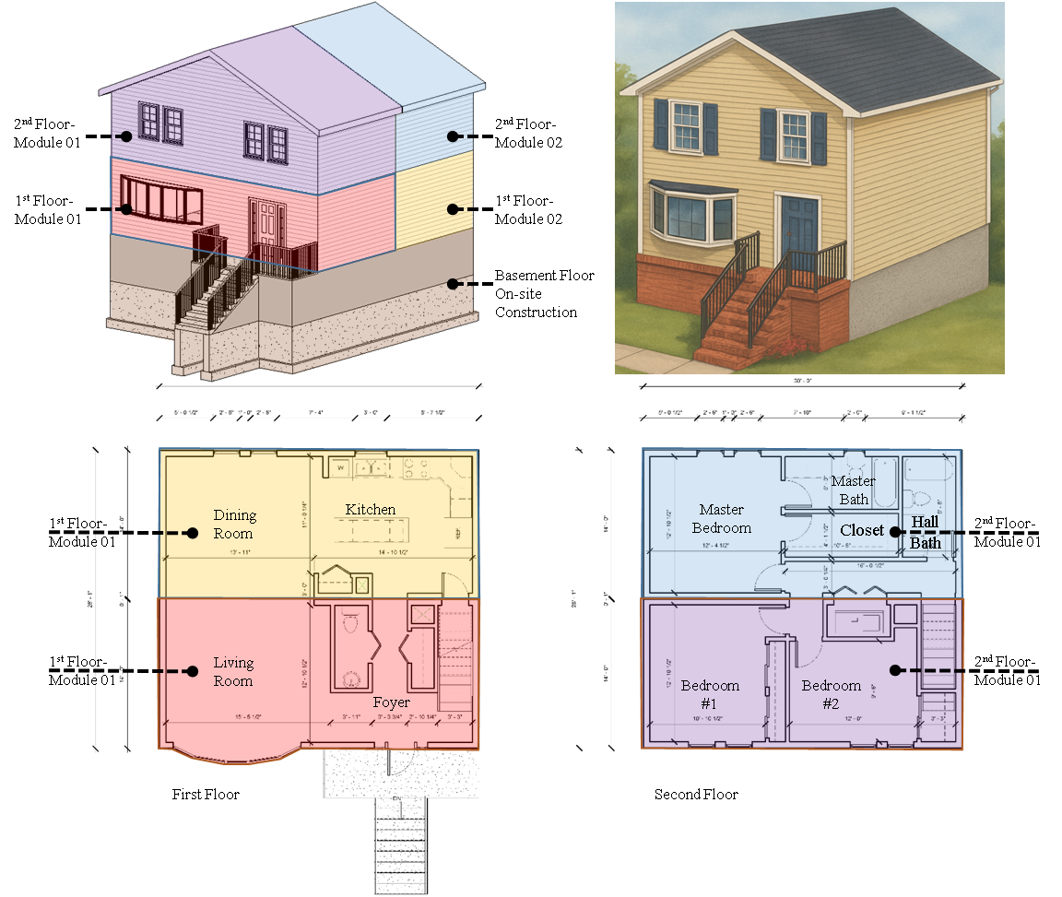
Case Study DTs: The Planning DT included early design and scheduling decisions; it managed the project building information model (BIM) for the homes and the master schedule, including module sequence and deadlines. The Off-site Digital Twin (DT) was created for a module fabrication facility roughly 100 miles from the main site, carefully balancing proximity and safety concerns related to coastal flooding. The facility specializes in producing standardized modules with optional finishing choices. Historically, the production time for each module averages five days, with a standard deviation of 0.5 days. The Logistics DT was designed to oversee module delivery from the plant to the site. Since there are 50 homes, each with four modules, totaling 200 modules to be transported, and assuming two modules per truck, the plan estimated around 100 truck trips. The logistics plan aimed to deliver modules in batches aligned with on-site foundation readiness, ensuring a steady flow of 10 modules delivered weekly, with adjustments as needed. Multiple routes were mapped: a primary route via interstate highways and a secondary, longer route on higher ground. The On-site DT was initialized with site conditions and the construction schedule. The 50 home lots were geographically distributed within a subdivision layout, imported as a GIS layer. The BIM models for each home, showing how four modules stack or connect on a foundation, were linked to their corresponding GIS coordinates. Before module arrival, site work includes building elevated foundations, which were also modeled. Assembly of modules was scheduled using a single crane capable of handling one module at a time.
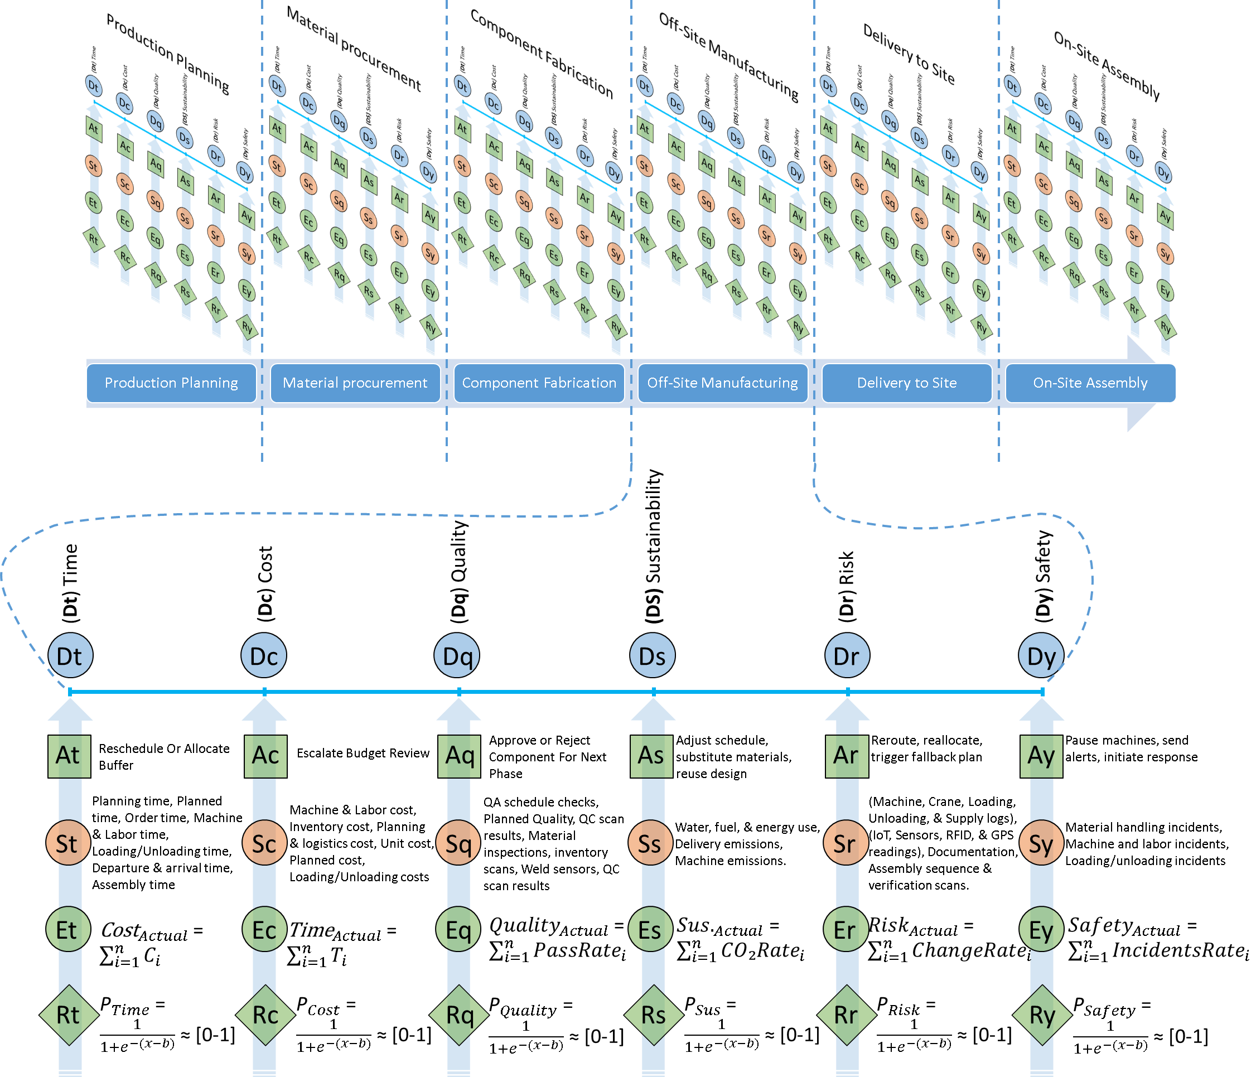
Case Study KPIs and Sensor Integration: The case study highlights six key performance indicators (KPIs): cost, time, quality, sustainability, risk, and safety. Each KPI is linked to sensor-based data streams, enabling continuous monitoring and analysis. Cost and time KPIs are determined by comparing planned and actual performance across project phases, using data such as RFID/GPS-enabled truck movements, fabrication cycle-time tracking, crane usage statistics, logistics costs, and schedule updates. Quality KPIs are monitored through IoT-enabled defect detection, compliance checks against design standards, and rework penalties, all based on sensor and QC scan data. Sustainability KPIs are measured using environmental sensors and smart meters that record energy use, water consumption, waste, and carbon footprint. Risk KPIs are assessed by integrating weather sensors, supply chain monitoring, and predictive analytics to evaluate vulnerability to delays or shortages. Safety KPIs rely on wearable devices, environmental sensors, and incident-tracking systems to monitor worker hours, ergonomic risks, and adherence to safety protocols.
These six KPIs emphasize the framework's connected, modular nature, in which digital twins across domains interact smoothly. Off-site sensors monitor fabrication accuracy, material usage, and waste reduction, affecting cost, quality, and sustainability KPIs. Logistics sensors provide real-time data on routing, environmental conditions, and delivery, affecting KPIs for time, cost, and risk. On-site sensors ensure that construction activities adhere to 4D BIM schedules, safety protocols, and environmental standards, addressing KPIs for time, safety, and sustainability. Merging these datasets transforms static benchmarks into dynamic, predictive indicators, enabling proactive decisions—such as reallocating resources, adjusting schedules, or improving safety. This integrated approach guarantees ongoing measurement, forecasting, and optimization of project performance within the digital twin ecosystem.
Using the uGridd Platform: The uGRIDD platform acts as a central hub for visualizing and integrating data in the case study, enabling smooth interaction between physical and their virtual aspects. It supports open formats like GIS, BIM, and IoT-derived JSON files, anchoring sensor data within geospatially accurate 3D and 4D models. This setup allows stakeholders to access dashboards that monitor the six KPIs in real time. For instance, project managers can view schedule progress, track cost changes, and assess sustainability metrics such as energy use and carbon emissions through a single, interactive interface. Additionally, the platform's interoperability enables future integration with predictive simulation tools, facilitating scenario analysis and foresight planning.
Beyond serving as a visualization and DataHub tool, uGRIDD enhances collaboration and composability by linking digital twins via shared ontologies and semantic data structures. This facilitates cross-domain interactions that reveal hidden dependencies, such as how supply chain risks affect on-site safety or how on-site delays influence sustainability by increasing energy use. By enabling bidirectional data exchange between digital twins, the platform transforms sensor data into actionable insights for proactive decision-making. In advanced work, platforms such as uGRIDD strengthen the case study's CCDT by integrating performance monitoring, risk prediction, and sustainability assessment into a unified operational framework.
PGM Implementation in Case: The study used the PGM described earlier to analyze this specific case. The Bayesian network included nodes for events such as "Module X fabrication delayed," "Truck carrying Module X stuck in traffic," and "Module X installed late on site," among others, with conditional links that show the process flow. This set up the model with initial knowledge; for example, historically, a fabrication delay of more than one day has an 80% chance of causing a site delay due to rework or resequencing. As the project advanced, actual data, such as fabrication and transit times, were entered to update the probabilities. The system logged every major event in the CDE event log, such as "Module #12 completed at factory at 10:00 AM, queued for shipment" or "Truck 3 departed at 6:00 AM, delay triggered at 8:30 AM due to road closure," with timestamps across twins, allowing us to trace causality during review. For example, the delay in the fabrication of Module #12 (off-site) was followed by the late departure of its delivery truck (logistics), which eventually led to overtime work during installation (on-site), creating a network linking all twins. These networks closely match the hidden goal of interaction analysis.
Another example of a probabilistic model that accounts for uncertainties involves adding a node for "Flood event during month," which influences the distribution of logistic delays and on-site work stoppages. Using historical climate data, this assigns a prior probability, such as a 20% chance of a significant flood during construction. As time passes without a flood, this probability decreases; however, observations of heavy rainfall can increase the likelihood of delays. Consequently, the CCDT can update risk estimates in real time: early in the project, it might predict a 60% chance of on-time completion; after a dry month and ahead-of-schedule progress, this could rise to 80%. Conversely, if a tropical storm causes a two-week halt, the estimate would decrease accordingly.

Relationships and Data Flow Between Off-Site and On-Site at Different Timesteps:
The data flow between the off-site manufacturing and on-site construction environments illustrates the relationships among the different DTs within the central modular housing system. Off-site processes produce data on prefabrication quality, material use, and production timelines, which are fed into the on-site DT to align with 4D BIM and project schedules. In turn, on-site progress, resource limitations, and installation performance are fed into the off-site DT, enabling manufacturing to adjust production rates, deliveries, and specifications. This exchange creates a continuous feedback loop that ensures alignment across DTs and supports real-time adaptive decision-making. This data flow forms three relationships across the different timesteps:
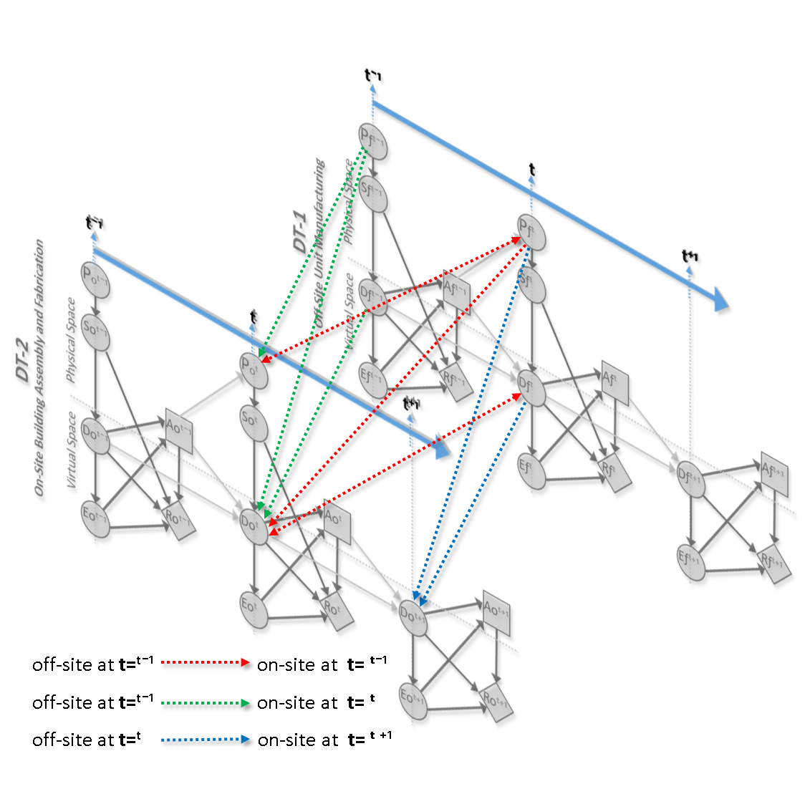
Same Timesteps: At the same timestep, the off-site digital twin (representing prefabrication and manufacturing) exchanges data directly with the on-site digital twin (representing construction and assembly). This flow is bidirectional: off-site sends data on fabrication status, logistics, and resource allocation, while on-site provides feedback on installation progress, material utilization, and schedule adherence. This maintains synchronization between what is produced and what is assembled.
Synchronic flow:
$$X_{on}(t)=f\left(X_{off}(t)\right)$$
Where $X_{off}(t)$ and $X_{on}(t)$ represent actual values, both off-site and on-site, across KPIs at the same timestep.
Initial and Current Timesteps: In CCDT environments, relationships exist not only in space but also over time, across different timesteps. At the initial timestep, digital twins record baseline data, including planned schedules, design models, and resource allocations. At the current timestep, physical progress and sensor data update the digital state, revealing deviations such as delays, cost overruns, or quality issues, which form the foundation for identifying risks or opportunities. The relationship here involves synchronizing physical reality with evolving digital models, with the initial baseline serving as a benchmark and the current state as a dynamic value. This temporal link enables evaluating performance, such as identifying how earlier fabrication delays affect current on-site risks.
Baseline vs. Current Performance:
$$ΔX(t)= X_{current}\left(t\right)- X_{initial}(t-1)$$
where $ΔX(t)$ indicates the deviation between planned and actual values across KPIs (cost, time, quality, sustainability, risk, safety). This comparison uncovers hidden discrepancies and supports adaptive decision-making.
Current and Future Timesteps (Prediction): The third data flow links the off-site state at the current timestep with the on-site state projected to a future timestep. Off-site sensors supply real-time data on component readiness, delivery schedules, and logistics. This data feeds into predictive models within the on-site system to forecast installation plans, resource needs, and safety strategies. Essentially, off-site data drives predictive synchronization, helping the on-site system anticipate delays, optimize labor deployment, and prepare contingency plans before physical issues arise. This flow shows how coupled, composable DTs go beyond reactive monitoring to support proactive decisions, connecting present states with future outcomes.
This predictive layer uses probabilistic models, conditional dependencies, and Bayesian updating. For instance, delays observed in off-site production at the current timestep influence predicted schedules, costs, and risks on-site at future timesteps. This enables proactive rescheduling, resource reallocation, and risk mitigation before problems arise.
Predictive Flow:
$$p{(X}_{on}\left(t+1\right)∣ X_{off}\left(t\right))= \prod_{i}{p{(x}_{i}\left(t+1\right)∣ p_{a}\left(x_{i}(t\right)}))$$
Where:
Left-hand side: $p{(X}_{on}\left(t+1\right)∣ X_{off}\left(t\right))$
Denotes the conditional probability distribution of the on-site digital twin state at the future timestep $\left(t+1\right)$, given the off-site digital twin state at the current timestep $\left(t\right)$. It answers: "Given the current production/fabrication data, what is the probability distribution of future on-site conditions (e.g., schedule, cost, safety outcomes)?"
Right-hand side (product rule): $\prod_{i}{p{(x}_{i}\left(t+1\right)∣ p_{a}\left(x_{i}(t\right)}))$
This expands the joint probability into a product of conditional probabilities of individual state variables $(x_{i})$.
$x_{i}\left(t+1\right)$: The value of the $i_{th}$ variable of the on-site system at the next timestep.
$p_{a}\left(x_{i}(t\right))$ : The parent nodes or influencing variables from the Bayesian Network at time $(t)$.
So, each future state variable, for example, installation progress, safety risk, cost variance, is conditioned on its parent dependencies, for example, delivery delays, fabrication quality, and weather conditions, at the current timestep. This follows the chain rule for Bayesian Networks, in which a joint distribution can be factorized as a product of conditional distributions given the graph structure. It means the prediction of the entire future state ($X_{on}\left(t+1\right)$) does not need to be computed in one step. Instead, we calculate the probability of each variable given its parents, and then multiply them together.
Relationship | Type of Interaction | Directional Flow | Example
Pfᵗ ↔ Poᵗ | Indirect, physical, Bi-directional | Pf → Logistics → Po | * Module fabrication completed → transported → site arrival  * Component returns, defects, circular economy
Pfᵗ → Doᵗ | Indirect, digital | Pf​ → Sensors/IoT → Do | The physical module progress updates the digital twin on-site
Dfᵗ ↔ Doᵗ | Direct, digital sync, Bi-directional | Df↔Do | Real-time digital synchronization of fabrication and assembly
Sfᵗ ↔ Soᵗ | Indirect, digital | Sf​ → Df↔Do ← So | Component tracking, real-time condition monitoring
Pfᵗ־¹ → Poᵗ | Indirect, physical | Pfᵗ־¹ → Logistics → Poᵗ | Module fabrication completed → transported → site arrival → instantiated
Pfᵗ־¹ → Doᵗ | Indirect, cyber-physical | Pfᵗ־¹​ → Sensors/IoT → Doᵗ | The physical module progress updates the digital twin on-site
Dfᵗ־¹ → Doᵗ | Direct, digital sync | Dfᵗ־¹ → Dƒᵗ ↔ Doᵗ | Real-time digital synchronization of fabrication and assembly
Pfᵗ → Doᵗ⁺¹ | Indirect, cyber-physical | Pfᵗ → Sensors/IoT → Doᵗ⁺¹ | The physical module prediction updates the digital twin on-site
Dfᵗ → Doᵗ⁺¹ | Direct, digital sync | Dfᵗ → Doᵗ ↔ Doᵗ⁺¹ | Predicting a digital twin on-site  of fabrication and assembly

Key Hidden Interactions Observed:
The case study revealed concrete examples of all four interaction types, validating our hypothesis:

PTPT Interaction (Physical Coupling):
A clear connection is the module flow itself. On several occasions, the factory's output schedule directly affected the site's physical activities. For example, midway through the project, the factory fell two days behind on a batch of modules due to a machine breakdown. This delay may not be immediately visible digitally; the Manufacturing DT recorded it, but that information did not reach the Assembly DT promptly. Physically, it meant no modules arrived at the site for an extra two days. We observed the on-site construction nearly cut off, with crews running out of modules to install. This is an unseen PTPT interaction; the physical absence of modules caused by off-site issues impacted the on-site physical system. Workers noticed idle time and reallocated to other tasks, such as site cleaning or preparing for future foundations, an ad-hoc physical response to a physical problem. The model identified this when the assembly progress indicator lagged behind schedule and strongly linked it to factory downtime. Once recognized, the project manager adjusted the delivery sequence for upcoming modules, reducing further idle time. This highlights both the risk, an unseen physical bottleneck leading to a standstill on-site, and the potential benefit, early detection allowing proactive rescheduling of on-site tasks.
This case illustrates how physical disruptions off-site can propagate through interconnected digital twin systems, creating latent dependencies between off-site and on-site operations. The predictive modeling of these interactions can be expressed mathematically as:
$$ΔX_{on}\left(t\right)= α . f( ΔX_{off}\left(t\right))+ ϵ$$
Where:
$ΔX_{on}\left(t\right)$ = deviation in on-site performance KPIs at time $\left(t\right)$ (e.g., labor productivity, equipment utilization, idle hours, % schedule slip).
$ΔX_{off}\left(t\right)$ = deviation in off-site performance KPIs at time $\left(t\right)$ (e.g., number of delayed modules, machine downtime).
$f( .)$ = functional relationship capturing the dependency of on-site state on off-site performance.
$α$ = coupling coefficient quantifying how strongly off-site disruptions correlated to on-site performance.
$ϵ$ = residual term capturing unobserved factors (e.g., weather, labor availability).
This highlights the risk of unrecognized PTPT interactions but also the opportunity to use predictive coupling models for proactive mitigation.

DTDT Interaction (Digital Coupling):
An example of this kind of coupling is the synchronization of schedule data, such as the hidden interaction between the Planning DT (master schedule) and the Assembly DT (field schedule). Ideally, the master schedule is updated only at major milestones, but in practice, site engineers may make ongoing updates to the Assembly DT to reflect current conditions. These two schedules gradually diverged. For example, when facing the delay mentioned above, the Assembly DT may delay several tasks by two days. The Planning DT, however, may not be immediately updated, as formal schedule updates occur at major milestones. During this gap, the Logistics DT, which referenced the master schedule for dispatch planning, worked with outdated information, creating a digital discrepancy. The Bayesian network could identify this issue by indicating a high probability that the "master schedule is outdated" given the observed delay pattern, thereby revealing a hidden DTDT inconsistency. After detection, a manual reconciliation of the schedules could be performed. Moving forward, the Assembly DT could also implement a mechanism for more frequent digital synchronization, posting daily updates to the Planning DT. This incident highlights a coordination risk arising from hidden DTDT interactions, in which misaligned data across twins can lead to suboptimal decisions. In this case, logistics is unaware that the site has delayed tasks, leading to early delivery plans. This fix adds value by making the interaction explicit through daily sync, keeping the twins aligned, and enhancing overall coordination.
- Schedule divergence (what goes wrong):
Here is an equation to formalize the DTDT discrepancy signal in the schedule at time $\left(t\right)$:
$$d\left(t\right)=S_{m}\left(t\right)- \sum_{i}{S_{i}\left(t\right)}, \left\|d(t)\right\|>δ means the twins are misaligned.$$
Where:
$d\left(t\right)$ : the schedule divergence (misalignment) at time t,
$S_{m}\left(t\right)$ : master/planning schedule (baseline),
$S_{i}\left(t\right)$ : DT $\left(i\right)$ schedule,
$δ$ : tolerance threshold (e.g., 1 day), then the system flags an out-of-sync condition.
On the other hand, a simple discrete update model at the timestep master updates, and the daily field updates are:
$$S_{i}\left(t+1\right)=S_{i}\left(t\right) + u_{i}\left(t\right), (site edits each day).$$
$$S_{m}\left(t+1\right)=\left\{ \begin{aligned}S_{m}\left(t\right) + u_{m}\left(t\right), t ∈ \left\{T_{k}\right\}\left(at timestep\right), \\ S_{m}\left(t\right), otherwise,\end{aligned}\right.$$
$$d\left(t+1\right)=d\left(t\right)+ u_{i}\left(t\right) - 1_{t ϵ \left\{T_{k}\right\}} . u_{m}\left(t\right)$$
Where:
$u_{i}\left(t\right)$ : continuous local DT input (e.g., Assembly DT) is updated at timestep t. These events occur daily (e.g., field engineers log delays and progress changes).
$u_{m}\left(t\right)$ discrete global correction to the master/planning schedule, applied at a milestone timestep t. These happen only in specific milestones.
$1_{t ∈ \{T_{k}\}}$ : an indicator function. It equals 1 if the current time t falls on an official master-schedule update day (i.e., $t ϵ T_{k}$​), and 0 otherwise.
$T_{k}$ : timestep index for updating the state of process k when the Planning DT is officially updated (e.g., bi-weekly).
This clarifies why there is a gap between master updates and can mislead downstream DTs (e.g., Logistics DT) that query. Each day, divergence increases due to ad hoc edits at the site. When a master update occurs, the divergence is decreased by $- u_{m}\left(t\right)$ Thus, the Planning DT becomes reconciled with the other DTs. However, if it is not a master update day and the indicator is 0, no correction is applied. This equation models the dynamic evolution of schedule divergence between DTs. For example, suppose
- Yesterday’s divergence: $d\left(t\right)$ = 3 (site is 3 days ahead of master).
- Today the site slips by 1 day: $u_{i}\left(t\right)$ = +1.
- Today is a master update day: $t ∈ \{T_{k}\}$​, with $u_{m}\left(t\right)$ = +3 (planner incorporates 3 days of changes).
Then:
$$d\left(t+1\right)=3 + 1 - 1⋅3 = 1$$
Therefore, after reconciliation, the misalignment shrinks to 1 day. However, If $t∉ T_{k}$, then $1_{t ∈ \{T_{k}\}}$ = 0, thus:
$d\left(t+1\right)= 3 + 1 - 0 . u_{m}\left(t\right) = 4$
Since there was no Planning DT reconciliation today, the new site edit exacerbates the misalignment. Divergence grows from 3 to 4, i.e., it drifts until the next master update day triggers the $u_{m}\left(t\right)$​ correction.

- Hidden inconsistency detection (Bayesian flag):
The goal here is to identify cases where the Planning DT (master KPI values) is not in sync with the other DTs, for example, the schedule KPI. The binary flag indicator $O\left(t\right) ∈ \left\{0, 1\right\}$ is what we want to detect probabilistically. If $O\left(t\right)=0$ , then the master schedule is still current. Otherwise, if it is = 1, then it is outdated.
$p(O\left(t\right)∣ \left\|d\left(t\right)\right\|, ∆T_{k})= σ(β_{0}+β_{1}\left\|d\left(t\right)\right\|+β_{2}∆T_{k})$, $σ\left(z\right)= \frac{1}{1+e^{z}}$
Where:
$\left\|d\left(t\right)\right\|$ : magnitude of divergence (gap between Planning DT and actual DTs performance).
$∆T_{k}$ : time since the last official master update.
$β_{0}, β_{1}, and β_{2}$ : coefficients learned from data or set by expert calibration.
$σ\left(z\right)$ : sigmoid function, giving probability between 0 and 1.
As the divergence grows, or as the master goes longer without an update, the probability that the master is outdated increases. If this probability crosses a threshold $δ$ (e.g., 0.7), then, the system flags $O\left(t\right)$=1.
$β_{0}$ (the intercept) baseline task confidence (when no problems exist) represents the baseline level of the dependent variable (e.g., task confidence) when all other factors (constraints, delays) are zero. In the TCL case, it would mean the “default” confidence level of completing a task on time in an ideal scenario with no violations or delays. $β_{1}$ (coefficient for constraint violations), penalty weight of constraint violations. This measures how much confidence decreases as the number of constraint violations (zone clashes, missing info, logical clashes) increases. A larger negative β₁ would mean each additional violation reduces the task confidence more strongly. $β_{2}$ (coefficient for delay factor), penalty weight for delays. This quantifies the sensitivity of the confidence level to delays. For example, if $β_{2}$ is large or even small, schedule delays sharply lower the predicted confidence.
There are two main approaches to determining the Values of $β_{0}, β_{1}, and β_{2}$. First, it can be done by using historical project data, such as records of delays, constraint clashes, and actual task outcomes, to run statistical regression (linear or logistic) or machine-learning fitting to estimate these coefficients. For example, suppose we have 200 activities with logged delays, clashes, and completion status (on time or late). In that case, we can fit the TCL equation to minimize the error between predicted and actual outcomes. The second approach involves expert elicitation and calibration. If historical data is limited, experts can provide estimated impacts, such as each zone clash reducing confidence by approximately 10%. These subjective values can then be calibrated as sensor/IoT and BIM data accumulate.
$$p{(X}_{i}\left(t+1\right)∣ S_{m}\left(t\right))= \prod_{i}{p{(x}_{i}\left(t+1\right)∣ p_{a}(S_{m}\left(t\right))})$$
$X_{i}\left(t+1\right)$ : the predicted state of the ith DT outcomes at the next timestep. This is the joint system state vector at t+1, comprising all the individual components. $x_{i}\left(t+1\right)$.
$x_{i}\left(t+1\right)$ : a single random variable of the larger system state $X_{i}\left(t+1\right)$ (or outcome) at the next timestep t+1, each $x_{i}$ could represent a specific logistics, cost, time, or quality variable tracked in the digital twin.
$p_{a}\left(S_{m}(t\right))$ : the parent nodes or influencing variables from the Bayesian Network at time $(t)$.
This expresses the prediction for DTs (e.g., truck arrivals) based on the Planning DT. The equation states that future DT outcomes, given the Planning DT, can be calculated as a product of conditional probabilities for each DT variable, based on its dependencies (parents) in the schedule. The Conditional Probability on the left hand expresses the probability of future logistics outcomes given the Planning DT’s schedule state at the current time. For example: “What is the probability that crane availability tomorrow, given what the master schedule says, trucks arrive on time today?”. While Bayesian Network Factorization on the right hand breaks down the joint distribution of logistics outcomes into a product of smaller conditional probabilities, following the Bayesian Network structure. Where each variable $x_{i}\left(t+1\right)$ (e.g., “Truck A arrives,” “Module B loaded”) depends only on its parents $P_{a}(S_{m}\left(t\right))$. For instance, if the Planning DT says, “Module #8 is scheduled today,” that affects whether a truck arrival is likely. This makes the computation tractable: instead of modeling everything at once, we model each variable locally, accounting for its dependencies.
Comparing predictions under $S_{m}\left(t\right)$ vs. $S_{i}\left(t\right)$ ​ reveals when the master schedule is stale. Therefore, if we replace $S_{m}\left(t\right)$ with $S_{i}\left(t\right)$ , as in Assembly DT’s field-updated schedule, and the predicted logistics outcomes change significantly, then the Planning DT is outdated. For example, if $S_{m}\left(t\right)$ = 90% for the activity “Truck arrival tomorrow” while $S_{i}\left(t\right)$ = 40% (since the site already reported a 2-day delay). That discrepancy indicates a hidden inconsistency.

PT–DT Interaction (Sensor-Driven Cross-Updates):
One of the most valuable hidden interactions was through IoT sensors that served as bridges between physical events and digital twins. The Logistics DT and Assembly DT were connected by GPS and RFID sensor data (physical signals) without direct human input. In one case, a delivery truck was held up by an accident, delaying the arrival of Module #8. The truck's GPS sensor data (physical twin information) fed into the Logistics DT, which marked the delivery as "delayed." However, no one explicitly informed the on-site assembly crew. Yet, the Assembly DT's predictive model detected the pattern; the PGM learned that a certain pattern in transit data often indicated an on-site start delay, so it updated the assembly forecast for the installation of Module #8 accordingly. The site superintendent, looking at the uGRIDD dashboard, noticed the module's icon flagged as "Delayed in transit" (the platform automatically visualized this because the Assembly DT subscribes to Logistics data feeds). This indirect physical-to-digital interaction allowed the on-site team to adapt (they shifted focus to other work while waiting). It demonstrated how real-time sensor integration can reveal hidden PT–DT links and turn them into actionable insights. In this case, the hidden interaction (traffic incident on-site schedule impact) was successfully detected and used via the digital system. The risk would have been if the sensor data had not been integrated, then the site would have been caught by surprise. Instead, by leveraging PT–DT connectivity, downtime was reduced.
- Infer logistics status from PT sensors (GPS/RFID)
Let $L_{t} ∈\{ontime,delayed\}$ be the (latent) logistics status at time t, and $z_{t}$ the stream of PT sensor observations at time t (GPS trajectory, RFID pings, telematics). A simple Bayesian filter fuses those signals into a posterior over the current logistics state:
$$p{(L}_{t}∣ z_{1:t})∝ p{(z}_{t}∣ L_{t})\sum_{L_{t-1}}{p{(L}_{t}∣ l_{t-1}) p{(l}_{t-1}∣ z_{1:t-1})}$$
Where:
$z_{1:t}$ : PT sensor observations from time 1 through t (GPS tracks, RFID scans, telematics).
$z_{t}$ : the new observation/measurement at time t.
$L_{t}$: Logistics DT state inferred from sensors (on-time / delayed).
$l_{t-1}$​: a specific value that the previous state $L_{t}$​ can take; the sum runs over all such values (i.e., over the state space).
$p{(L}_{t}∣ z_{1:t})$ : the posterior belief over the current state after incorporating observations up to t.
$p{(z}_{t}∣ L_{t})$ : the measurement likelihood—how probable the current observation is if the state were $L_{t}$​.
$p{(L}_{t}∣ l_{t-1})$ : the state transition (motion) model—how likely the system moves from one state $l_{t-1}$​ to $L_{t}$​.
$p{(l}_{t-1}∣ z_{1:t-1})$ : the previous posterior belief (at time t−1) over the state.
This is the DT side “listener” that turns raw physical signals into a probabilistic logistics status.
- Propagate to the Assembly DT (cross-update)
Let $A_{k,t}$​ denote the random start status/time of Assembly task “install Module k” by time t. Condition Assembly’s forecast on the inferred logistics state:
$$p{(A}_{k,t+1}∣ z_{t})=\sum_{l_{t} ∈\{ontime,delayed\}}{p{(A}_{k,t+1}∣ l_{t}=l) P{(L}_{t}=l∣ z_{t})}$$
This is simply the law of total probability used to predict the assembly starts for Module K at t+1; it averages the conditional forecast under each logistics state $l$ weighted by the current probability that $l$ is true given the sensors.
Operationally, $P{(L}_{t}=l∣ z_{t})$ is produced by the Logistics DT’s filter, for example, a Bayesian updater that turns GPS/RFID into “on-time vs delayed” probabilities, while $P{(A}_{k,t+1}∣ l_{t}=l)$ is a small conditional model that says, for example, “if delayed, the install start shifts by two days.”
Equivalently, we can rewrite this in scheduled time using expectations:
$$E{[S}_{k}∣ z_{t}]=S_{k}^{plan}+E{[∆}_{k}∣ z_{t}], E{[∆}_{k}∣ z_{t}]=\sum_{l }{∆_{k}\left(l\right)p{(L}_{t}=l∣ z_{t})}$$
Where:
$S_{k}$​ : DT tasks start status/time for Module K.
$S_{k}^{plan}$ : the baseline from the master schedule.
$∆_{k}$: Delay applied to $S_{k}^{plan}$​ based on $L_{t}$, for example, traffic-induced +2 days when “delayed”.
So, the Assembly DT’s forecasted start is “plan + expected delay,” where the expected delay is a probability-weighted average over logistics states computed from live sensors. Practically, this is the sensor-driven cross-update: nobody has to call the site; the Assembly DT subscribes to the Logistics DT’s posterior $P{(L}_{t}∣ z_{1:t})$, updates $E{[∆}_{k}∣ z_{1:t}],$, and automatically shifts the task start (and UI flags like “delayed in transit”). The benefit is fewer surprises and less idle time: actionable assembly forecasts react to real-world transit changes in near real time and surface them clearly on the CDE dashboard.
These equations generate the automated “delayed in transit” flag and adjust the Assembly DT’s forecast without requiring manual input. For example, if $P{(L}_{t}=on-time∣ z_{t})=0.3$ and $P{(L}_{t}=delayed∣ z_{t})=0.7$ and $∆_{k}(on-time)=0$ days while $∆_{k}(on-time)=2$ days, then
$E{[∆}_{k}∣ z_{t}] =0.3⋅0+0.7⋅2=1.4$ days, so the Assembly DT shifts the forecasted start by +1.4 days relative to plan.
- Hidden-interaction detector
A mutual-information detector measures how much the PT sensor stream up to time t (GPS, RFID, telematics) changes the forecast distribution for a future assembly outcome $A_{k,t+1}$​, for example, start/finish time or status for module k at horizon t+1. If the value is large and positive, then the sensors are materially driving the on-site assembly forecast right now; i.e., a hidden PT→DT coupling has “lit up,” so it should surface an alert/annotation like “sensor-driven update” on the Gantt.
Quantify that a physical signal is materially driving a DT forecast by monitoring information flow (useful for alerts/QA):
$$I{(A}_{k,t+1}∣ Z_{1+t})= E[log\frac{p{(A}_{k,t+1}∣ Z_{1:t}=z_{1:t})}{p{(A}_{k,t+1})}]$$
Where,
$A_{k,t+1}$ : a random variable capturing the assembly DT outcome for module k at a future horizon t+1, for example, predicted start time bin, delay category, or continuous start time.
$Z_{1+t}$ : the entire sensor history up to time t from the Physical Twin logistics stream (including GPS trajectory, RFID pings, and telematics features). Think of this as everything the trucks/fleet have reported so far.
$p{(A}_{k,t+1}∣ Z_{1:t}=z_{1:t})$ : the posterior forecast for the assembly outcome given the actual sensor history observed to date, this is what your coupled DT pipeline produces after fusing sensors into the logistics DT and propagating effects to assembly.
$p{(A}_{k,t+1})$ : the marginal (prior) forecast for the assembly outcome without conditioning on the current sensor stream, for example, the schedule forecast from plans plus historical variability, or yesterday’s forecast before new sensor evidence arrived.
$log\frac{p{(A}_{k,t+1}∣ Z_{1:t}=z_{1:t})}{p{(A}_{k,t+1})}$ : the information gain (in nats if natural $log$; in bits if $\log_{2}$). It’s positive when today’s sensors make a particular outcome more (or less) plausible than the unconditioned baseline.
$E[.]$ : expectation over the joint distribution of ${(A}_{k,t+1}, Z_{1+t}$). Operationally, you average the log-ratio across the sensor histories you observe (or sample) to obtain a single scalar that measures the net information flow at this moment.
$I{(A}_{k,t+1}∣ Z_{1+t})$ : this is mutual information between the future assembly outcome and the current sensor history. If $I>0$ (or crosses a threshold), the PTDT dependency is active and should be surfaced on the dashboard (e.g., annotate the Gantt with “sensor-driven update”, and equals 0 if and only if sensors and that assembly outcome are (conditionally) independent, i.e., no active PTDT influence now.
When PT sensors begin to alter the on-site Assembly DT forecast, for example, a truck stalls → predicted start for module k slips), the posterior $p{(A}_{k,t+1}∣ Z_{1:t}=z_{1:t})$ diverges from the prior $p{(A}_{k,t+1})$. That divergence is exactly what the log-ratio and expectation quantify; cross a tuned threshold and you flag “sensor-driven update” on the dashboard.
These equations illustrate the hidden PTDT coupling of the observations; physical sensor signals (such as a truck stuck in traffic) are processed to update the Logistics DT, and that updated posterior influences an immediate probabilistic adjustment in the Assembly DT’s schedule forecast and UI flags.

DTPT Interaction (Digital Commands to Physical Processes):
An important example of a digital-to-physical twin interaction occurred during the final stage of the project. The Assembly DT, connected via the uGRIDD interface, detected a defect during module installation: one wall panel lacked an embedded electrical conduit. Using the platform, the on-site manager submitted a digital rework request, which was sent directly to the Manufacturing DT. This command was immediately relayed to the physical factory queue, reordering tasks and instructing factory workers to produce a replacement panel. In this way, the digital twin of the on-site system directly affected the physical twin of the off-site facility, triggering immediate corrective production.
While this interaction was intentionally designed as part of the feedback loop, it revealed hidden side effects. Reallocating factory resources to address the defect delayed production of the next scheduled module. This disruption could have cascaded into logistics, impacting downstream deliveries. However, the Probabilistic Graphical Model (PGM) integrated into the CCDT framework detected this ripple effect by increasing the probability of a late delivery for subsequent modules. To mitigate the risk, the project team proactively booked an extra truck (resource buffer) for the next shipment, preventing delay propagation.
This episode highlights both the benefits and dangers of DTPT interactions; a digital command resolved an immediate quality issue but also introduced the risk of new disruptions elsewhere. The key lesson is that bi-directional coupling between digital and physical twins requires thorough oversight. Corrective action in one twin (rework order) can inadvertently create problems in another (production or logistics). Using a centralized probabilistic monitoring system, the team balanced these conflicting effects, ensuring the defect was fixed and that the subsequent delivery remained on schedule.
- Digital command → factory queue & capacity
Let $C_{k}(t) ∈\{0,1\}$ flag a rework command for module K issued from the Assembly DT at time t. When $C_{k}\left(t\right)=1$, the Manufacturing DT reprioritizes the shop queue and allocates capacity (labor/machine-hours) to the rework job​, which reduces the effective capacity available to the next scheduled job $N_{k+1}$​:
$μ_{eff}\left(t\right)= μ_{0}- θ_{cr} C_{k}(t)$, ${∆T}_{N_{k+1}}\left(t\right)= \frac{max\{0,{ w}_{r}-slack(t)\}}{μ_{eff}\left(t\right)}$
This represents the physical queueing slowdown resulting from a digital rework order. Where,
$C_{k}(t) ∈\{0,1\}$ : Binary rework command flag for module K at time t, then $C_{k}(t)=1$: rework is triggered now. $C_{k}(t)=0$ : no rework command.
$N_{k+1}$ : the next scheduled (non-rework) job in the factory queue after module K.
$μ_{0}$ : baseline processing capacity of the relevant workstation(s) (units: workload per unit time, e.g., machine hours per hour). such as the service rate when no rework is stealing capacity.
$θ_{cr}$ : capacity-reduction coefficient (same units as $μ$). It quantifies the processing rate loss when a rework command is active. We can parameterize it as $θ_{cr}=ϕμ_{0}$ with $ϕ ∈(0,1]$ to interpret it as a fraction of baseline capacity.
$μ_{eff}\left(t\right)=μ_{0}-θ_{cr}C_{k}(t)$ : effective capacity available to the normal queue at time t. If $C_{k}(t)=0:μ_{eff}=μ_{0}$ (no loss). However, if $C_{k}(t)=1:μ_{eff}=μ_{0}-θ_{cr}$ (capacity diverted to rework).
${ w}_{r}$ : the rework workload that must be processed before $N_{k+1}$​ can start (units: workload, e.g., machine hours or labor hours).
$slack(t)$ : time buffer currently available before $N_{k+1}$​’s planned start (units: time, e.g., hours).
${∆T}_{N_{k+1}}\left(t\right)= \frac{max\{0,{ w}_{r}-slack(t)\}}{μ_{eff}\left(t\right)}$ : predicted delay imposed on the next job $N_{k+1}$ at time t (units: time). The numerator compares the required rework time vs the available slack.
This means that if rework (in time units) exceeds slack, the excess must spill into the schedule; if not, the delay is zero. Dividing by $μ_{eff}\left(t\right)$ converts residual workload (numerator is in workload units if ${ w}_{r}$​ is given that way) into time, using the reduced service rate.
When the Assembly DT issues a rework command for module K at time t, i.e., it sets a binary flag, the Manufacturing DT reprioritizes the factory queue and diverts capacity to the rework job $R_{k}$​. That diversion reduces the effective capacity available for the next scheduled job $N_{k+1}$​, which can induce a delay if the rework exceeds the available slack. For example, suppose $μ_{0} = 16$ machine-hours/hour, $θ_{cr}=8$ machine-hours/hour, and $C_{k}(t)=1$ $μ_{eff}\left(t\right)=8$. If the rework is ${ w}_{r}=12$ machine-hours, and the available slack is 4 hours, then
$∆T= \frac{max\{0, 12-4\}}{8} =\frac{8}{8}=1 hour delay$
This matches the slide’s story: a digital rework command diverts capacity, slows the station, and pushes the next job unless there is sufficient slack.
- Propagate to logistics & on-site (predictive ripple)
Define a manufacturing state $M_{t}$​ e.g., {on-time, delayed} inferred after the command. The delivery-delay probability for the next module propagates via total probability:
$$p\left(D_{k+1}=1 | C_{k}=1, z_{1:t}\right)=\sum_{m}{p\left(D_{k+1}=1 | M_{t}=m\right) p\left(M_{t}=m | C_{k}=1, z_{1:t}\right) }$$
Where,
$D_{k+1}$ : an event that will be in the next module $k+1$ will be delivered late at the next step.
$C_{k}=1$: a command/action just occurred for module K (e.g., rework request); we condition on that because it can change the factory state.
$z_{1:t}$​ : sensor history up to t (shop/telematics/PLC feeds).
$M_{t}∈\{on-time,delayed,…\}$ : manufacturing state at time t inferred by the Manufacturing DT (e.g., via HMM/BN filtering).
$p\left(D_{k+1}=1 | M_{t}=m\right)$ : the probability of delivering the next Module (K+1) late, given the factory’s current state.
$p\left(M_{t}=m | C_{k}=1, z_{1:t}\right)$ : the inferred probability that the factory is in state “$delayed$”, given both the rework command “rework request” and sensor history up to t.
The equation is the law of total probability; it calculates the late-delivery chance under each manufacturing state $m$ by the current probability that the factory is in state $m$ given $C_{k}=1, z_{1:t}$. What it means: the system first infers how the factory is doing right now $p\left(M_{t} | .\right)$, then maps that to a late-delivery risk for $k+1(p\left(D_{k+1}=1 | M_{t}\right))$, and sums over states. This is the PGM cross-update that raised the late-delivery risk once rework consumed capacity.
For example,
Suppose $p\left(D_{k+1}=1 | M_{t}=delayed\right)=0.6$, $p\left(D_{k+1}=1 | M_{t}=on-time\right)=0.1$, $p\left(M_{t}=delayed | C_{k}=1, z\right)=0.7$, and $p\left(M_{t}=on-site | C_{k}=1, z\right)=0.3$. Then,
$p\left(D_{k+1}=1 | C_{k}=1, z_{1:t}\right)=0.6⋅0.7+0.1⋅0.3=0.45$ (45% late risk).
At the scheduled time, the expected start shift for the downstream on-site task becomes
$E{[S}_{k+1}∣ z_{1:t}, C_{k}=1]=S_{k+1}^{plan}+\underset{factory}{\underbrace{{∆T}_{N_{k+1}}\left(t\right)}}+\underset{logistics}{\underbrace{E[∆_{k+1}^{log}∣ z_{1:t}, C_{k}=1]}}$,
With $E[∆_{k+1}^{log}∣ .] =\sum_{l}{∆^{log}(l) p\left(L_{t}=l | z_{1:t}\right)}$ if the logistics DT tracks states $l∈\{ontime,delayed\}$.
$S_{k+1}$ ​: planned start (from the master/field schedule).
${∆T}_{N_{k+1}}\left(t\right)$ : factory-induced processing delay that pushes $k+1$ later (e.g., queueing/throughput effects).
$E[∆_{k+1}^{log}∣ .]$ : expected logistics delay computed from live transit signals. This logistics term is expanded as a state-weighted expectation:
$$E[∆_{k+1}^{log}∣ .] =\sum_{l}{∆^{log}(l) p\left(L_{t}=l | z_{1:t}\right)}$$
where $L_{t}$​ is the logistics state (e.g., on-time/delayed) inferred from GPS/RFID.
This means the corrected on-site start for $k+1$ equals the plan, plus the factory delay and the expected transit delay from the current logistics posterior.
For example,
If $S_{k+1}^{plan}=Day 20$, ${∆T}_{N_{k+1}}\left(t\right)=0.8 day$, and $p\left(L_{t}=l | z_{1:t}\right)=0.4 day$ with $∆^{log}\left(l\right)=1.0 day$, then
$E\left[∆_{k+1}^{log}\right]=0.4 day$and
$$E\left[S_{k+1}\right]= 20+0.8+0.4= Day 21.2$$
- Mitigation by resource buffer (extra truck/overtime)
When a digital command (like a rework order) stresses the factory, we can reduce downstream delay risk by adding resources (an extra truck or overtime). Choose a mitigation control $μ(t)= (b,o)$ where $b ∈\{0,1\}$ adds an extra truck (1 = yes, 0 = no) and $o≥0$ is overtime that boosts the base capacity to $μ_{eff}\left(t\right)=μ_{eff}\left(t\right)+ ηo$. Then, the post-mitigation late probability and expected slippage become:
$p^{+}\left(D_{k+1}=1 | C_{k}=1, u\right)=\sum_{m}{p\left(D_{k+1}=1 | M_{t}=m,b\right) p\left(M_{t}=m | C_{k}=1, o,z_{1:t}\right) }$,
$${∆T}_{N_{k+1}}^{+}\left(t\right)= \frac{max\{0,{ w}_{r}-slack(t)\}}{μ_{eff}\left(t\right)}$$
This is the same law-of-total-probability structure as before. Still, here the terms are conditioned on the mitigation decision $u=(b,o)$, which means, with an extra truck or overtime, the manufacturing state posterior shifts, thereby lowering the overall chance of late delivery.
Select $μ(t)$ to minimize the expected penalty $J=α E[∆T]+β p(D=1)+γCost(b,o)$ (weights α,β,γ>0). This combines expected delay time (weighted by $α$), probability of being late (weighted by $β$), and mitigation cost (weighted by $γ$) to choose $μ(t)$ (truck/overtime decision) that minimizes $J$. It captures the choice to add a truck, so the delivery window remained on time despite the rework.
To read these together, the DT command $C_{k}=1$ reprioritizes the physical factory, consuming capacity, and extends the next job’s processing time ${∆T}_{N_{k+1}}$​​. The Manufacturing DT’s posterior over states $M_{t}$ raises the delivery-delay probability, which the Logistics/Assembly DTs ingest to shift downstream schedules. A mitigation action $u(t)$ (extra truck and/or overtime) reduces both the expected time loss and the delay probability, trading off cost vs. risk. These equations give you a crisp DTPT causal chain (command → queue/capacity → delay risk) and a control handle to keep the system balanced; exactly what your team executed.
Overall, the case study supported the hypothesis that hidden interactions exist and are significant. Each type of interaction was successfully identified using the methods; the PGM highlighted statistical dependencies that matched real events, such as those above, and the event log review verified the timing and impact. In each example, once the interaction was recognized, the project team could respond to improve coordination by synchronizing data, rescheduling tasks, and adding buffers. This demonstrates the practical value of uncovering hidden interactions; it leads to tangible actions that enhance workflow (e.g., reducing idle time and preventing misinformation). The case also revealed the risks: when interactions go unnoticed, even briefly, issues like idle crews or misaligned plans emerge. Notably, no catastrophic failures occurred, but we believe this is because the framework caught most issues in time. It suggests that future projects could benefit from implementing such detection mechanisms early on as a warning system, increasing resilience.

Results and Discussion

